**Wireframe Documentation**

Fraud Transaction Detection

**Homepage**

We have divided credit card fraud detection System’s Homepage into Two Sections: -

1. First thing anyone will see is a pop-up window on the Homepage which will ask for User Inputs.

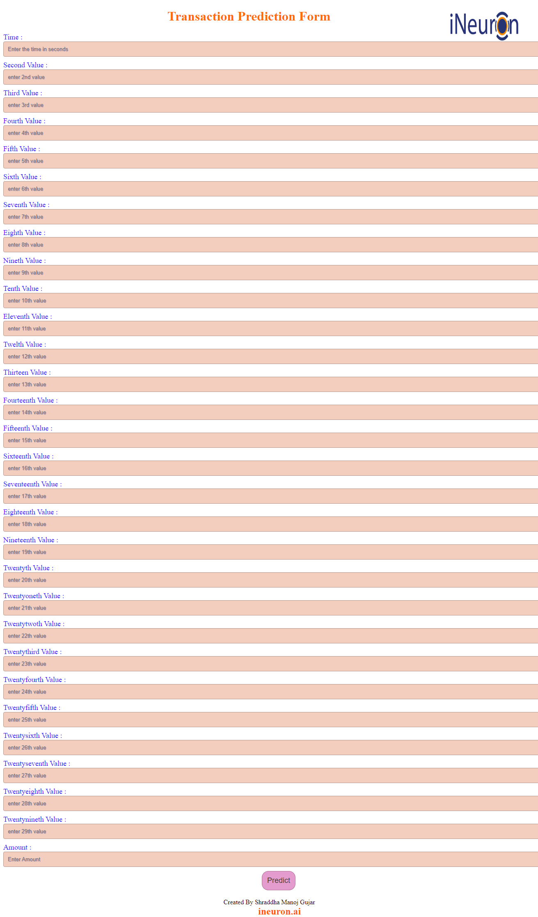

1. The User will encounter another pop-up window print out the transaction is Fraud or not.

